Wellfield Care Ltd

SHARING THE CARING – AUTUMN ISSUE 10

A Newsletter written by Wellfield and the Residents.

Once again it is the time of year when we update you all on topical issues since the last newsletter.

Outings

It seems an age since Kath took some of the ladies to Ewloe Church Summer Fete and Gladys Jones and Winnie Edwards enjoyed the W.I. Strawberry Tea in Hawarden. We managed to pick some good weather for outings in the early part of the summer.

We had a very successful day when we held our open coffee morning on Saturday 17 August. We raised a grand sum of £319.54. This replenished the residents outing and entertainment fund.
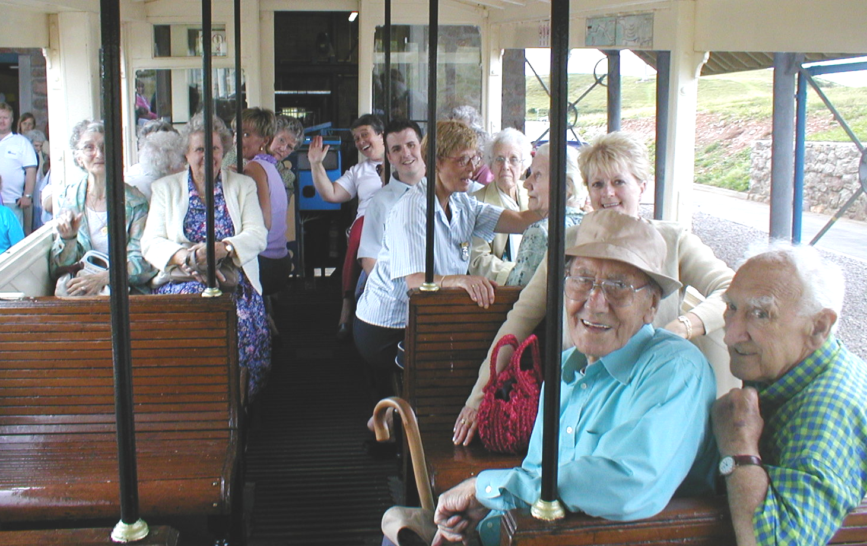
Remember in August, when we hired a coach and about 20 residents and staff went to Llandudno and the fun and games getting onto the Orme railway? A good job the weather was kind to us. A great day was had by all

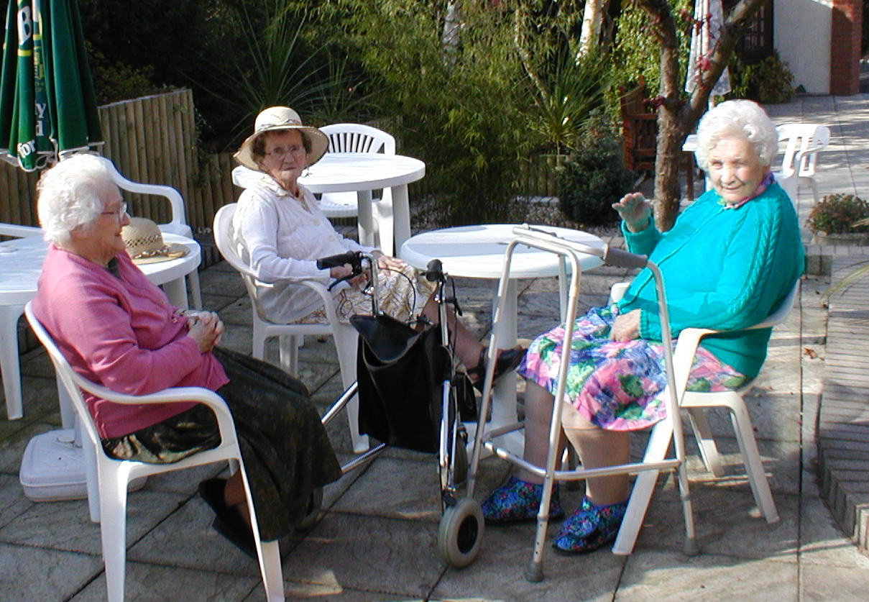

During the rest of summer, the weather wasn’t too good to enjoy the patio and gazebo, but I recall one afternoon when Sylvia, Kitty and Annie, were sitting outside in summer frocks and straw hats. Annie’s niece Joyce arrived and was telling us how hot it was in Mold, t-shirts and shorts weather. When do you think it was? Not August or September, but the beginning of October! What a difference a few weeks make, last weeks storms signalled autumns here with a vengeance.

VISITS

We had a visit on St David’s Day from children at the Busy Bees playgroup. They looked lovely in their welsh costumes and brought daffodils and a lot of smiles to us all. The children also enjoyed their visit as they came to see us again at Easter, with Easter Eggs for all the residents.

Local Councillor David Parry called at Wellfield, bringing newsletters and he stayed for a chat.

Recently, Professor Nick Bourne, Conservative Leader of the Welsh Assembly and Mathew Wright, the prospective assembly candidate for Alyn & Deeside, visited Wellfield for a chat with us all.

NEW RESIDENTS WELCOME

A very warm welcome is extended to new residents and their families, Bob Haime, Jenny Howard, Sarah Neal, Elizabeth Ahier, Erne White, Edna Wharton and Mary Thompson. We hope they have a very happy time with us.

As a reminder for relatives, please check the notice board in the hallway through the lounge, for any letters placed there for your attention.

TRAINING

There is barely a week goes by lately, when we are not training for something. It is all part of the bigger picture I will try to explain later on, but thanks to all the staff for attending, mostly over and above their normal working times.

CHRISTMAS CALENDER OF EVENTS

To date, we have confirmed bookings in December for the following entertainment, to ensure a great time is had by all:

Music with Rodger, singing with the Cub Scouts, shopping with Flair, singing with Sounds Familiar Choir, singing with Ivor Walker, shopping with Lloyds Chemist, singing with Kath’s choir, singing with Betty Findlay, Resident’s concert with Rodger and a visit from the Salvation Army. A detailed list will be available soon.

If any relatives are planning to take Resident’s out over Christmas, please let Joan know as soon as possible.
NEW EDITOR

Welcome to Wendy our new Editor. Peter will help to write the script for our newsletter and Wendy will edit. Any comments or input is greatly welcomed.

STAFF PROFILE

This time Tristan has volunteered! Tristan writes, “I originally came to work at Wellfield on placement from College some 10 years ago. I must have done something right, because I was offered a job as the 1st male carer. After 2 years, I decided to broaden my spectrum of care in the Health Service. Now 8 years on, I am back a lot wiser and experienced. Again, I must be doing something right, to be offered Senior Care Trainee, culminating (I hope!) to be Senior Care by the end of this year, as I’ve now achieved Level 3 NVQ and attend all the study days going.

I love the place, the residents and staff, especially when my jokes are appreciated!

When I’m not hear, my interests include, amongst the obvious, 10 pin bowling, pool and car driving. I hope to pass my motorcycle test next summer…. you want to see the look on Mr Robert’s face, when I say maybe I’ll buy one!

Well, that’s my turn over, and another 27 to go, before its me again. By then, it maybe me that’s asking others to volunteer!

A NEW ERA BEGINS

Since 1984, Care Homes have been registered under the Residential Homes Act of that year. As from April of this year, the new regulatory requirements of the Care Standard Act 2000, came into force. A new department came into being, namely the Care Standards Inspectorate for Wales (CSIW).

Each home has to re-register under the new act with the CSIW . This takes place after the CSIW have inspected the home to the new minimum standards. A report will be published and made public stating whether we conform or partly conform to the 40 new standards, each with their sub-sections covering:- Information, Needs Assessment, Capacity to meet needs, Trial Visits, Contract, Service User Plan, Record Keeping, Autonomy and Choice, Social Content and Opportunities, Community Contact, Rights, Confidentiality, Intermediate Care, Personal Care – Privacy and Dignity, Health Care, Meals and Mealtimes, Medication, Safe Working Practices, Dying and Death, Staffing Levels, Staff Qualifications, Recruitment, Staff Training, Staff Supervision, Volunteers, The Registered Manager, Ethos, Quality Assurance, Financial Procedures, Service User’s Money, Complaints, Protection, Premises, Shared Facilities, Lavatories and Washing Facilities, Adaptations and Equipment, Individual Accommodation – Space Requirements & Furniture and Fittings, Heating, Lighting and Water, Hygiene and Control of Infection.

We at Wellfield now know the Standards. Ask, Hazel, Joan or Wendy, how many forests were felled for paper, how many hundreds of hours, checking existing documents and producing new, were required. How many headache tablets consumed, sometimes Wine instead. It really has been a mammoth task and is still ongoing.

The staff have had to undertake even more training and will continue to do so. Some of the physical changes to the building have been widening dining room doorways, covering over 75 radiators with radiator guards and putting mixer valves on all hot water outlets to restrict the temperature to approximately 43⁰C.

We have also produced a comprehensive guide to all the services and facilities at Wellfield, entitled Statement of Purpose containing 47 pages.

A summary entitled ‘Service Users Guide’ will be produced and sent to all residents or next of kin.

The full Statement of Purpose will be made available to read by request.

Your views and comments are always important to us. We endeavour to be the best and appreciate the involvement of families and friends when possible.

Although there is not extra funding at the moment from Social Services, towards bringing homes and staff to the standards we hope some will become available by April 2003.

Sadly, as you have no doubt heard or read in the press, some homes have closed or are contemplating this.

As the crisis deepens and hospital bed blocking becomes more acute due to the shortage of places in homes for the elderly to be discharged to, no doubt government funding will be found from somewhere. Something like shutting the stable door comes to mind!

Not withstanding, as you are all aware, Wellfield has been continually upgrading and re-investing and will meet the standards or thereabouts. We eagerly await our full inspection on 2 December and the subsequent reports.

CRIMINAL RECORDS BUREAU (CRB)

After the inspection and new registration all new staff will have to have clearance from CRB before becoming permanent staff. All existing staff will need to have CRB clearance by April 2003.

STAFFING

Care staff are now beginning to be recognised as a professional and having completed NVQ and comprehensive training will become registered with the Care Council for Wales. This will in effect, become a passport to Care and the status (at last) will be properly recognised and I amongst many others, will be pushing hard for wages to match this status. You can help by talking to your local politicians. This could really make a difference. Thanks on behalf of them all.

LIGHTER NOTES

What is this I hear about the electric Scooter Grand Prix from here to the Co-op with ‘Bob’ and ‘Erne’. The odds are on Erne, until Bob get used to his new one. It’s great for them to get out and about. Come on Ladies – who’s for a Scooter!

A BIT OF THE MEDITERANEAN AT WELLFIELD

What do you think of the re-vamped dining room with its bright Mediterranean looks? We feel it creates a lovely warm and bright ambience, for our residents to enjoy their meals in.

VISITORS BOOK

As part of the new Standards, we need to remind Visitors that there is a visitor’s book in reception for recording your visits and comments if you wish.

RESIDENTS CORNERS

Kindly given from Mrs Jones’s personal Anthology:

Fear not the shadows, ‘tis the sunshine that makes them.

‘Tis not what you see, but the Company in which you see it, that makes things delightful.

Today is the Harvest of yesterday and the seedtime of tomorrow.

Many people have a good aim in life, but forget how to pull the trigger.

